
Bruce. A Weinberg

Department of Economics
Ohio State University
1945 North High Street
Columbus, OH 43210-1172

Phone: (614) 292-5642
Fax: (614) 292-3906

May 23, 2012

Professor William Masters
E-mail to: Vankeerbergen.1@osu.edu

Dear Mitch:

This letter is to accompany the proposed Naval Science Minor. We discussed this minor at our May 18th meeting. The minor is a new minor that is likely to appeal to ASC students. (It also seems to parallel the revised Air Science Minor, which we also approved.) There was an extended discussion of the fact that the minor includes 12 credit hours at the 2000-level or higher. In addition, 2 1000-level courses are required. While this structure conforms to the language adopted by the ASC CC earlier this academic year, at least one knowledgeable member of the subcommittee felt that there was a still preference to include 1000-level courses in prerequisites rather than as requirements and the subcommittee would be grateful for any clarification. Aside from that issue, the minor was viewed as a valuable addition for ASC students and the subcommittee approved it unanimously.

Sincerely,
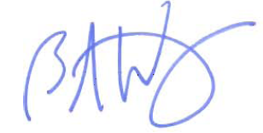
Bruce A. Weinberg
Professor and Director of Undergraduate Studies

